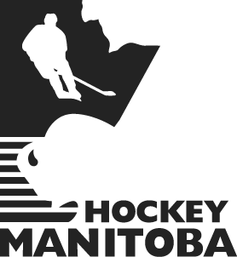

Program of Excellence
Hockey Manitoba
200 Main Street
Winnipeg, Manitoba
R3C 4M2
www.hockeymanitoba.mb.ca

For Immediate Release
November 7, 2008

“MANITOBA TAKES CARE OF ALBERTA 4-1”

Napanee, ON

Team Manitoba played a sound game on both sides of the puck that lead to a 4-1 victory over Team Alberta. Manitoba limited Alberta to 23 shots, as much of the play took place in the Alberta zone with Manitoba finishing with 30 shots. Leiette Klassen got the nod in goal for Manitoba and put on a steady performance with 22 saves.

Manitoba goals came from Christine Bestland, Rachele Bosc, and two from Breann Frykas. The speed of Team Manitoba turned out to be too much for the Alberta defenders, which allowed for Manitoba’s best offensive performance thus far.

Assistant captain Brittany Hergesheimer credits Team Manitoba for “handling adversity well and bouncing back with a win.” Looking ahead to Manitoba’s next game she says “we just have to take it one shift at a time and take care of the little things.”

Manitoba finishes the preliminary round with a record of 2-1-0 and now solely holds 2nd place in Pool B. The Team awaits the outcome of BC (1-1-0) vs Quebec (2-0-0) before final standings are complete. Please stay tuned to the Team Manitoba Online Headquarters for more details.

For daily Team Manitoba game updates please visit http://www.hockeymanitoba.mb.ca/teammanitoba08.php.
This page will be the Team Manitoba Online Headquarters for news, updates, and detailed game summaries during the National Women’s U-18 Championships. Press releases will also be sent from the Nationals to local media on a regular basis, Nov 4th – 10th.

For more information:
Kyle Prystupa
Director of Operations
204-999-4120 (Cell)
kyle@hockeymanitoba.mb.ca

-30-

